Ques.1=> Create a database name social media.
Ans.1=>db.insta.insertMany
([
{userID:1, username:"Ananya", followers: 120, following : 80 , posts: 25},
{userID:2, username:"Rohit", followers: 540, following : 300 , posts: 112},
{userID:3, username:"Neha", followers: 980, following : 400 , posts: 210},
{userID:4, username:"Arjun", followers: 75, following : 120 , posts: 15},
{userID:5, username:"Trisha", followers: 230, following : 150 , posts: 60}
])
db.insta.find()
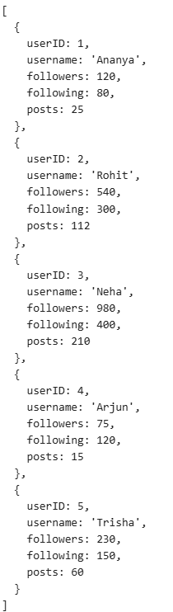
Ques.2=>create a table data and create 10 records in it.
Ans.2=> db.data.insertMany([
{ empId: 1, name: "Amit", department: "IT", salary: 45000, experience: 2 },
{ empId: 2, name: "Neha", department: "HR", salary: 38000, experience: 1 },
{ empId: 3, name: "Rohit", department: "Finance", salary: 52000, experience: 3 },
{ empId: 4, name: "Ananya", department: "Marketing", salary: 41000, experience: 2 },
{ empId: 5, name: "Arjun", department: "IT", salary: 60000, experience: 5 },
{ empId: 6, name: "Priya", department: "Support", salary: 32000, experience: 1 },
{ empId: 7, name: "Sneha", department: "Design", salary: 48000, experience: 3 },
{ empId: 8, name: "Vikas", department: "Sales", salary: 35000, experience: 2 },
{ empId: 9, name: "Ananya", department: "IT", salary: 55000, experience: 4 },
{ empId: 10, name: "Riya", department: "Operations", salary: 40000, experience: 2 }
])
db.data.find()
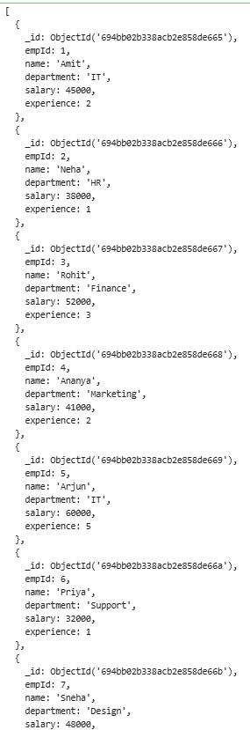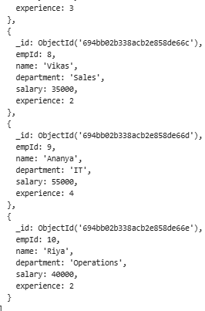
Ques.4=> Apply aggregation to the table.
Ans.4=> db.data.insertMany([
{ empId: 1, name: "Amit", department: "IT", salary: 45000, experience: 2 },
{ empId: 2, name: "Neha", department: "HR", salary: 38000, experience: 1 },
{ empId: 3, name: "Rohit", department: "Finance", salary: 55000, experience: 3 },
{ empId: 4, name: "Ananya", department: "Marketing", salary: 41000, experience: 2 },
{ empId: 5, name: "Arjun", department: "IT", salary: 40000, experience: 5 },
{ empId: 6, name: "Priya", department: "Support", salary: 55000, experience: 1 },
{ empId: 7, name: "Sneha", department: "Design", salary: 48000, experience: 3 },
{ empId: 8, name: "Vikas", department: "Sales", salary: 35000, experience: 2 },
{ empId: 9, name: "Ananya", department: "IT", salary: 55000, experience: 4 },
{ empId: 10, name: "Riya", department: "Operations", salary: 40000, experience: 2 }
])

db.data.aggregate([ {$match: {
$expr: {
$gt : [
{$add: ["$salary","$experience"]},
50000]}}}
])
db.data.aggregate([{ $group: {
_id:"$department",
maxSalary:{$max: "$salary"},

}}])
db.data.aggregate([
{
$group: {
_id: "$department",
minsalary: { $min: "$salary" }
}
}
]);
db.data.aggregate([
{
$group: {
_id: "$department",
totalsalary: { $sum: "$salary" }
}
}
]);

db.data.aggregate([
{
$group: {
_id: "$department",
avgsalary: { $avg: "$salary" }
}
}
]);
db.data.find().pretty()

